|  |  |
| --- | --- |
| **EGC Upward & Onward Logo** | Student Name _______________________  **Eastern Goldfields College**  Year 11 Mathematics Essential 2019  Task 6: Test 4  Working time: 20 minutes Marks: 171 |

**No calculator or notes for this section.**

**Question 1** (5 Marks – ½ each)

Complete the table by choosing the best **Data Display** and **Data Type** from the options provided.

You can choose each option more than once.

**Data Type**

* Numerical
* Categorical

**Data Display**

* Column graph
* Dot Plot
* Back to back stem and leaf diagram
* Histogram
* Box & whisker Plot

|  |  |  |
| --- | --- | --- |
|  | **Data Display** | **Data Type** |
| The heights (measured to the nearest cm) of 20 boys and 20 girls to compare them. |  |  |
| The eye colour of all Year 11 students. |  |  |
| The foot length of the members of your class |  |  |
| House prices in various suburbs |  |  |
| The birth month of all Essentials students. |  |  |

**Question 2** (7 Marks – 3, 1, 1, 2)

Below are the results of a survey, gathered by a Kalgoorlie phone shop. They were looking at the phone ownership of two major phone brands.

**Mobile Phone Owners**

|  |  |  |  |
| --- | --- | --- | --- |
| **Type of Phone** | Male | Female | Total |
| **iPhone** | 36 |  | 86 |
| **Samsung** |  | 45 | 67 |
| **Total** |  | 95 | 153 |

a) Complete the missing entries in the table above.

b) Which brand was the most common?

c) How many males own a Samsung phone?

d) Would a line graph be suitable to display this data? Explain why or why not.

|  |
| --- |
|  |
|  |
|  |
|  |

**Question 3** (5 Marks – 1, 1, 1, 2)

The column graph below shows the **average monthly rainfall** in Perth, in mm.



a)List two (2) key features that are missing from this graph? (1/2 mark each – Maximum 1 mark)

b)Which month had the lowest average monthly rainfall?

c)What was the average monthly rainfall for April?

d)Estimate thetotal rainfall for June, July and August?

|  |  |
| --- | --- |
| **EGC Upward & Onward Logo** | Student Name _______________________  **Eastern Goldfields College**  Year 11 Mathematics Essential 2019  Task 6: Test 4  Working time: 30 minutes Marks: 271 |

**Calculator assumed and one A4 page of notes permitted.**

***Show all working wherever necessary to maximise marks.***

**Question 4** (3 Marks – 1, 2)

The following dot plot shows the days between failure of the Maths Department photocopier.

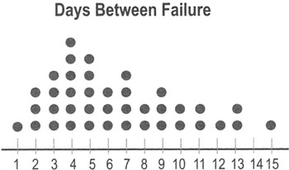

1. What is the most common amount of days before the photocopier fails?
2. The next time the photocopier fails, do you predict it will occur in more or less than 7 days’ time? Explain why.

### Question 5 (9 marks – 1, 1, 1, 2, 2, 2)

John Applecore began his apple orchard in 1996. The first apples were picked in 1999. The graph below shows the harvest for 5 years.

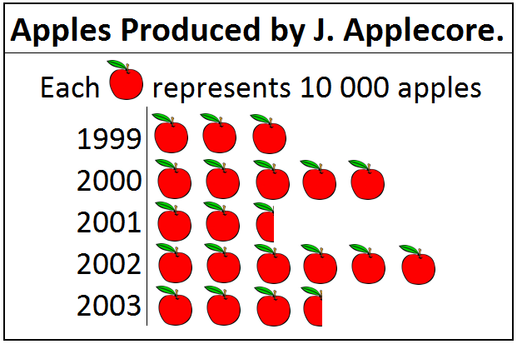

1. What kind of graph is this?
2. In which year was the harvest greatest?
3. What was the harvest in 2003?
4. Which year did the harvest increase the most? Justify your answer.
5. What percentage of the apples picked between 1996 and 2000 were picked in 1999?
6. In 2003 John paid Julie 20 cents per apple to pick the complete harvest. How much was she paid?

### Question 6 (5 marks)

Below is a table with Tanya’s height at each birthday from 2 years to 16 years old. Each height has been measured to the nearest centimetre.

|  |  |  |  |  |  |  |  |  |  |  |  |  |  |  |  |
| --- | --- | --- | --- | --- | --- | --- | --- | --- | --- | --- | --- | --- | --- | --- | --- |
| Age in years | 2 | 3 | 4 | 5 | 6 | 7 | 8 | 9 | 10 | 11 | 12 | 13 | 14 | 15 | 16 |
| Height  (cm) | 86 | 94 | 103 | 108 | 115 | 121 | 128 | 133 | 140 | 147 | 154 | 158 | 163 | 165 | 166 |

1. Use the grid below to graph the above information.

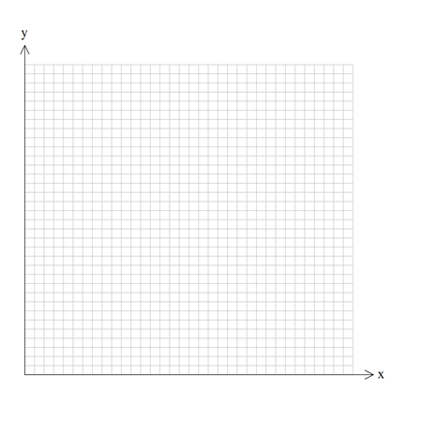

**Question 7** (4 Marks – 1, 1, 1, 1)

The Deputy Principal at Winnibap College has taken a small sample of 6 students and recorded their Mathematics and Science scores. The sample is shown below in a Histogram.

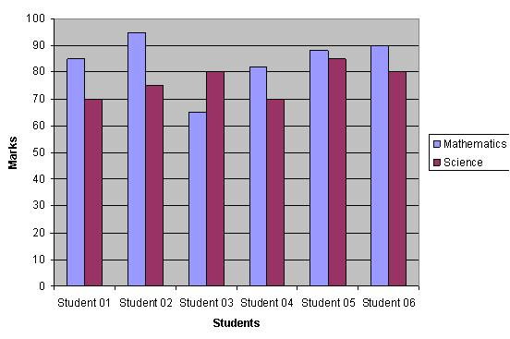

1. Which student provided the best Mathematics score?
2. Which student provided the worst Science score?
3. Which student’s Mathematics and Science scores are the closest together?
4. Overall, do you think the students perform better at Mathematics or Science? Justify your answer.

**Question 8** (6 marks – 2, 2, 2)

The following Pie Chart shows the proportion of sales that a wholesale market sells:

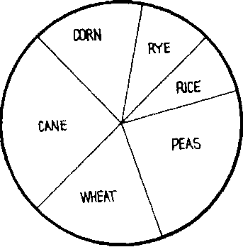

a) Which two items do they sell the most of?

b) Which two items do they sell the least of?

c) Which two items are *most likely* to each be worth 15% of the share? Explain why.